**A Project Report On**

**EPIC RPGRPG**

Submitted in partial fulfillment of the requirement for the award of the degree

MASTER OF COMPUTER APPLICATIONS

(M.C.A.)

Academic Year 2025 – 26

**Adil Belim (92400584032)**

**Krupali Shah (92400584055)**

**Niyati Bhanani (92400584019)**

|  |
| --- |
| **Internal Guide** |

Prof .Dr. Ashwin Dobariya



Rajkot-Morbi Road, At & PO : Gauridad, Rajkot 360 003. Gujarat. India.



**Faculty of Computer Applications (FCA)**



**This is to certify that the project work entitled**

**EPIC RPG V2**

**submitted in partial fulfillment of the requirement for**

**the award of the degree of**

**MASTER OF COMPUTER APPLICATIONS**

**(M.C.A.)**

**of the**

**Marwadi University**

**is a result of the bonafide work carried out by**

**Adil Belim (92400584032)**

**Krupali Shah (92400584055)**

**Niyati Bhanani (92400584019)**

**during the academic year 2025-26**

|  |  |  |  |  |
| --- | --- | --- | --- | --- |
| **Faculty Guide** |  | **HOD** |  | **Dean** |

**DECLARATION**

We hereby declare that this project work entitled **EPIC RPG V2**  is a record done by us.

We also declare that the matter embodied in this project is genuine work done by us and has not been submitted whether to this University or to any other University / Institute for the fulfillment of any course of study.

Place:

Date:

**Adil Belim (92400584032) Signature:**

**Krupali Shah (92400584055) Signature:**

**Niyati Bhanani (92400584019) Signature:**

**ACKNOWLEDGEMENT**

It is indeed a great pleasure to express my/our thanks and gratitude to all those who helped me/us. No serious and lasting achievement one can ever achieve without the help of friendly guidance and co-operation of so many people involved in the work.

We are very thankful to our faculty guide **Dr. Ashwin Dobariya,** the person who makes us follow the right steps during project work. we express my/our deep sense of gratitude to his/her guidance, suggestions and expertise at every stage. Apart from that his/her valuable and expertise suggestion during documentation of my/our report indeed helped me/us a lot.

Thanks to our friends who have been a source of inspiration and motivation that helped me/us during our project work. we are heartily thankful to our external guide **Dr. Ashwin Dobariya** for providing us an opportunity to work over this report and for their endless and great support. We are also thankful to our Head **Dr.Sunil Bajeja** and Dean **Dr. Rijwan Khan** for their support as and when required. we would like to extend our gratitude towards all who directly or indirectly supported and helped us to accomplish our project work.

**Adil Belim (92400584032) Signature :**

**Krupali Shah (92400584055) Signature :**

**Niyati Bhanani (92400584019) Signature :**

**COMPANY PROFILE**

**GALMINE AI**

Galamine AI is a technology-driven company specializing in Artificial Intelligence solutions that help organizations automate processes, improve customer engagement, and enhance operational efficiency. The company develops AI-powered chatbots, virtual assistants, and customized digital solutions to support business growth and innovation.

Galamine AI operates under Amri Foundation, an organization committed to innovation, social impact, and sustainable development through technology and education.

**CONTENTS**

|  |  |  |
| --- | --- | --- |
| **Chapters** | **Particulars** | **Page No.** |
| **1** | **SYNOPSIS** | 1 |
| **2**  2.1  2.2  2.3  2.4  2.5  2.6 | **PREAMBLE**  General Introduction  Statement of Problem  Objective and Scope of the Study  Module Description with functionality  Methodology  Feasibility Study | 2 |
| **3**  **3.1**  **3.2** | **REVIEW OF LITERATURE**  Review of Literature **:-** Basic Theory of the Game  Study of Existing Similar Systems **:- Zork** | 4 |
| **4**  4.1  4.2 | **TECHNICAL DESCRIPTION**  Hardware Requirement  Software Requirement | 5 |
| **5**  5.1  5.2  5.3  5.4  5.5  5.6  5.7  5.8 | **SYSTEM DESIGN AND DEVELOPMENT**  Flowchart  Data Flow Diagram (DFD)  DFD Level 0  DFD Level 1  Use Case Diagram  Sequence Diagram  Activity Diagram  Menu Design  Screen Design | 6 |
| **6**  6.1  6.2  6.3  6.4 | **SYSTEM TESTING**  Testing and Implementation  Testing Methodology  Test Case Design  System Implementation Strategy | 13 |
| **7** | **CONCLUSION** | 15 |
| **8** | **LEARNING DURING PROJECT WORK** | 16 |
| **9** | **BIBLIOGRAPHY**  Online References | 17 |

**FIGURE INDEX**

|  |  |  |  |
| --- | --- | --- | --- |
| **Sr. No.** | **Figure No.** | **Particulars** | **Page No.** |
| 1 | 5.1 | Flow chart | 6 |
| 2 | 5.2 | DFD Level 0 | 7 |
| 3 | 5.3 | DFD Level 1 | 7 |
| 4 | 5.4 | Use Case Diagram | 8 |
| 5 | 5.5 | Sequence Diagram | 9 |
| 6 | 5.6 | Activity Diagram | 10 |
| 7 | 5.8 | Screen Design | 12 |
|  |  |  |  |

**Table Index**

|  |  |  |  |
| --- | --- | --- | --- |
| Sr No. | Table No. | Particular | Page No. |
| 1 | 6.3.1 | Taste case | **13** |

* + - 1. **SYNOPSIS:**

The Text-Based Python RPG Game is an interactive command-line role-playing game developed using Python. The game allows users to register, log in, create characters, explore different areas, battle creatures, earn rewards, collect items, and level up. It is designed using a modular approach with separate components for user management, gameplay mechanics, inventory, store, and utilities.

The game uses JSON-based file storage to save and load player data such as username, password, stats, coins, XP, and inventory. The goal of the project is to provide a simple yet engaging RPG experience while demonstrating Python programming concepts such as functions, loops, file handling, conditional logic, and modular coding.

This project focuses on text-based interaction instead of graphics, making it easy to run on any system with Python installed. It serves as both entertainment and a practical application of core programming skills.

**2. PREAMBLE**

**2.1 General Introduction:**

Text-based RPGs (Role-Playing Games) are one of the earliest forms of computer games, built entirely through text prompts and user choices. These games are simple yet highly interactive, relying on decision-making rather than graphics.

**2.2 Statement of Problem:**

Many beginner programmers find it difficult to understand how real games manage player progress, combat, and rewards. Most examples available are either too simple to be engaging or too complex to understand. This project aims to solve that problem by creating a simple, text-based RPG using basic Python, where core game mechanics like combat, crafting, inventory, and progression are easy to follow, modify, and learn from

**2.3 Objective and Scope of the study:**

* Implement user registration and login functionality.
* Created a system for character level progression and attribute management (health, XP, coins).
* Design and developed various game modules, including hunting, adventure, inventory
* management, a store, and character profiles.
* Incorporate file-based storage for user data persistence.
* Provide a user-friendly text-based interface with clear instructions and feedback.
* **Scope:**
* The project will include core RPG elements such as character development, combat, and
* inventory.
* The game will be text-based, focusing on gameplay mechanics rather than graphical
* presentation.
* User data will be stored in a JSON file.
* The game will be developed using Python 3.x.

**2.4 Module Description with functionality:**

**2.4.1 User Management Module:**

* Description: This module handles user registration, login, and deletion.
* Functions:
* register(): Creates a new user account, storing the username and password.
* login(): Authenticates existing users and retrieves their data.
* delete_user(): Removes a user account from the system.
* load_user_data(): Loads user data from the JSON file.
* save_user_data(): Saves user data to the JSON file.

**2.4.2 Game Mechanics Module:**

* Description: This module contains the core gameplay functions, including hunting,
* adventure, chopping, and reward systems.
* Functions:
* rpg_hunt(): Simulates a hunting expedition where the player encounters creatures, gains
* rewards, and loses health.
* rpg_adventure(): Presents a more challenging adventure scenario with a single, powerful
* creature.
* rpg_chop(): Allows the player to chop wood and gather resources.
* reward(): Provides random rewards to the player.
* get_level(): Calculates the player's level based on their XP.
* check_level_up(): Checks if the player has leveled up and updates their stats

**2.4.3 Inventory Module:**

* Description: Manages the player's items.
* Function:
* view_inventory(): Displays the items currently in the player's inventory.

**2.4.4 Profile Module:**

* Description: Displays the player's character information.
* Function:
* view_profile(): Shows the player's username, level, stats (attack, defense, health), coins, and XP.

**2.4.5 Store Module:**

* Description: Allows the player to buy items from a store.
* Function:
* store(): Displays the store's inventory and handles purchases.

**2.4.6 Main Game Module:**

* Description: The main entry point of the game, orchestrating the game loop and user
* interaction.
* Function:
* start_game(): Manages the main game loop, user input, and calls other modules.

**2.4.7 Utils Module:**

* Description: Provides utility functions and data structures used across other modules.
* Functions/Data:
* get_level(): Calculates the player's level.
* item_emojis: A dictionary mapping item names to emojis for display.

### 3. Review of Literature

### 3 .1 Review of Literature :- Basic Theory of the Game

* Role-playing games work on the idea that a player starts with limited abilities and improves over time by playing the game. As the player performs actions like fighting enemies or collecting items, they gain experience, level up, and become stronger.
* Most RPGs use concepts such as health, experience points, inventory, and equipment to show player progress. This project follows the same basic idea but keeps everything text-based so the logic behind the game is easy to understand and learn

### 3.2 Study of Existing Similar Systems :- Zork

* One of the earliest examples of a similar game is Zork, a popular text-based adventure game released in the late 1970s. In Zork, players explored a fantasy world by typing commands, solving puzzles, and collecting items.
* It did not use graphics, but still managed to be engaging and immersive. This project takes inspiration from games like Zork by using text interaction, while also adding modern RPG features such as combat, levelling, crafting, and inventory management. The focus is on simplicity and learning rather than complex graphics.

## 4. Technical Description

## 4.1 Hardware Requirements

* Processor: Intel / AMD processor or equivalent
* RAM: Minimum 2 GB (4 GB or more recommended)
* Storage: 200–300 MB free disk space to support future game data, save files, logs, and feature expansions
* Display: Terminal or console window
* Input Device: Keyboard

**4.2 Software Requirement**

* Windows: Windows 10 or later
* Linux: Modern Linux distributions
* macOS: macOS 11 or later

**5. System Design and Development**

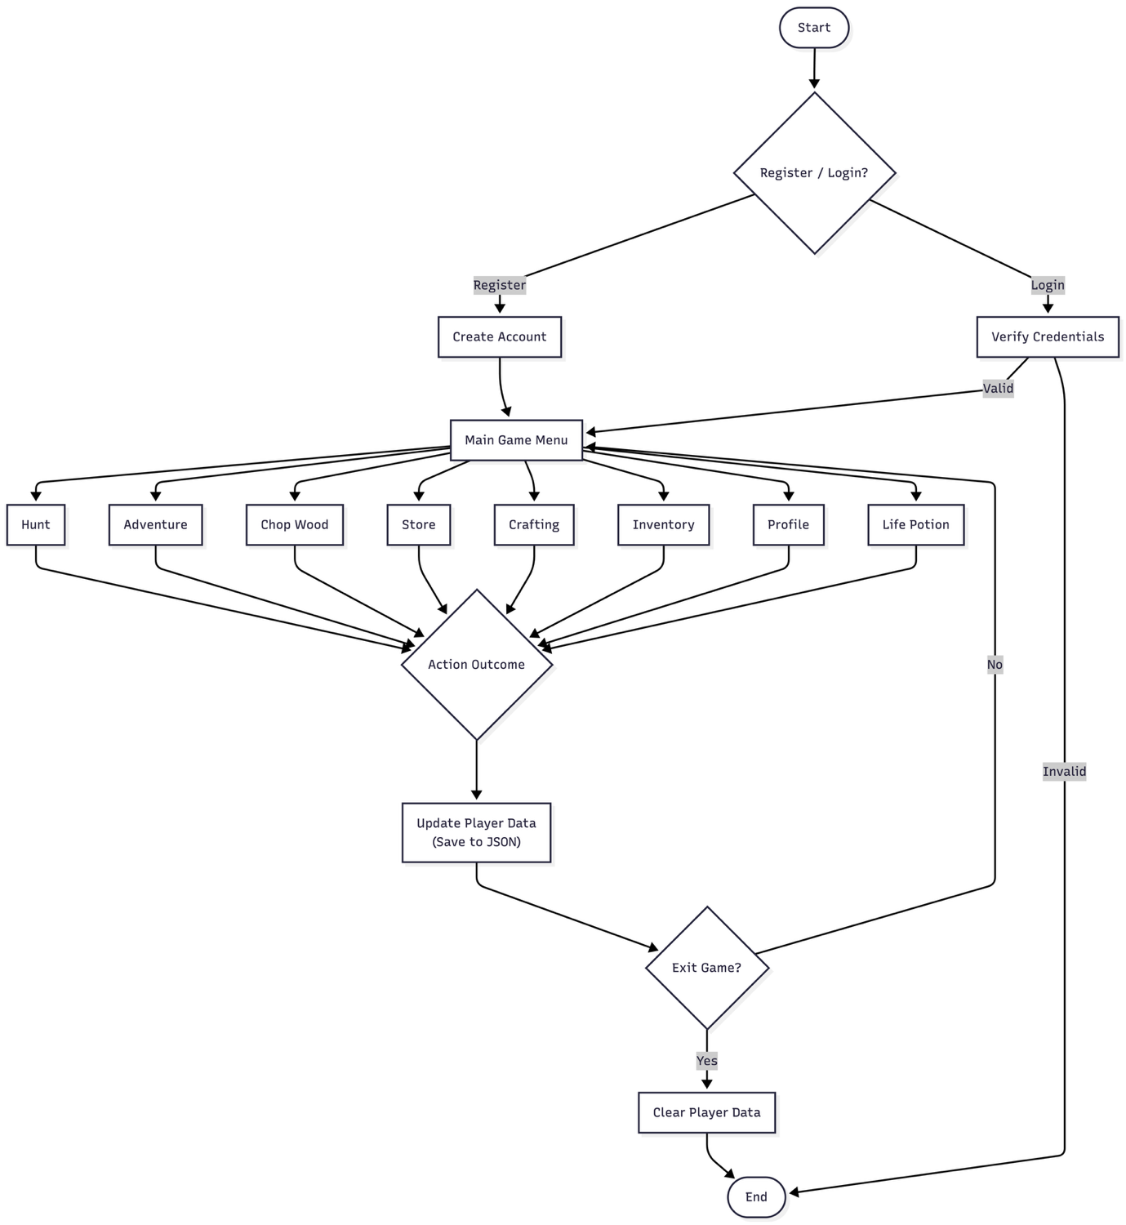**5.1 Flowchart:**

**Data flow diagram:**

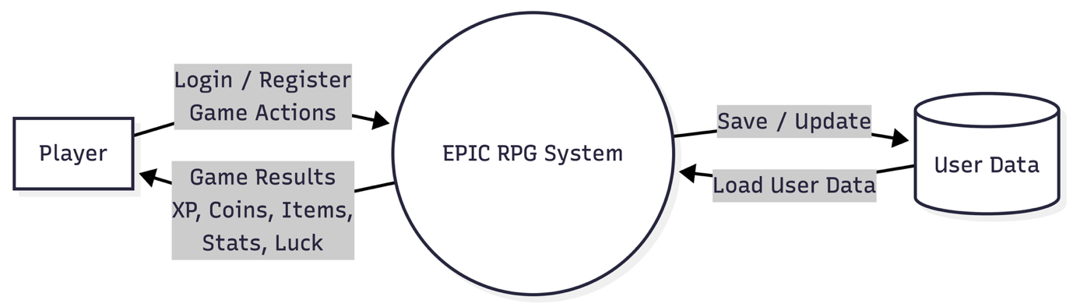**5.2 DFD-0**

**5.3 DFD Level-1:**

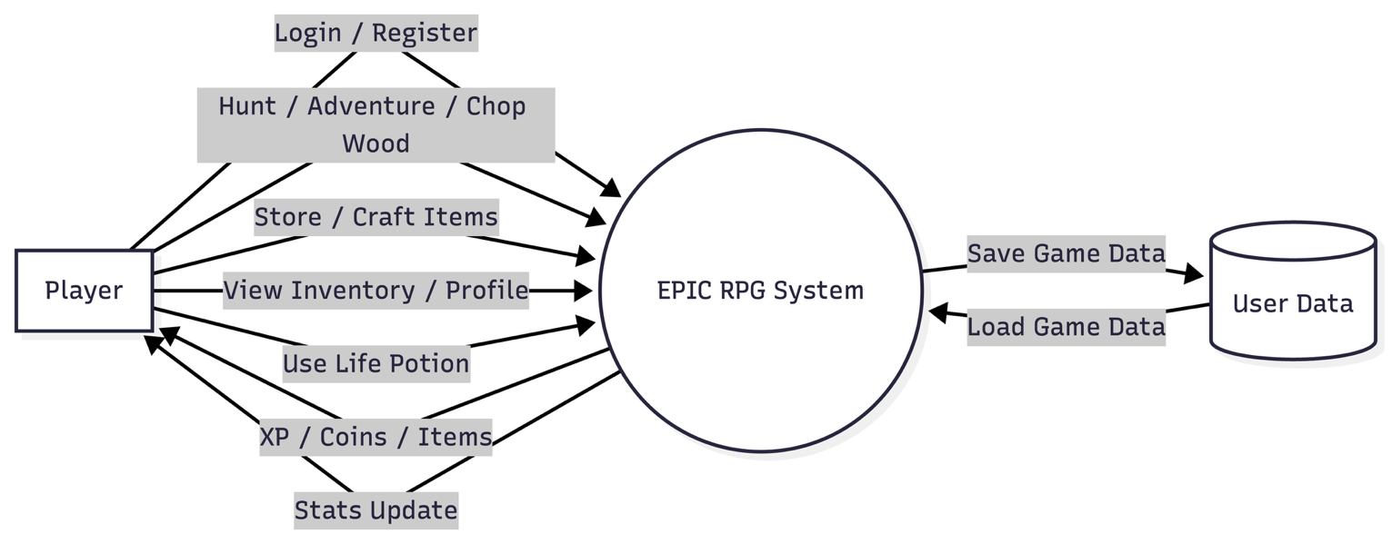

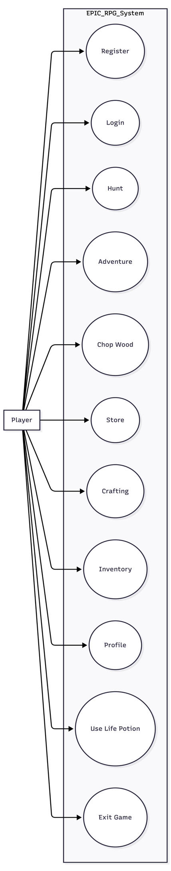**5.4 Use case diagram:**

**5.5 Sequential diagram:**

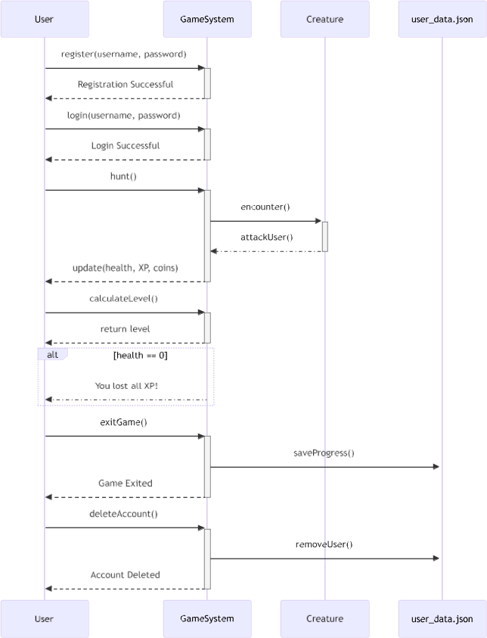

**5.6 Activity diagram:**

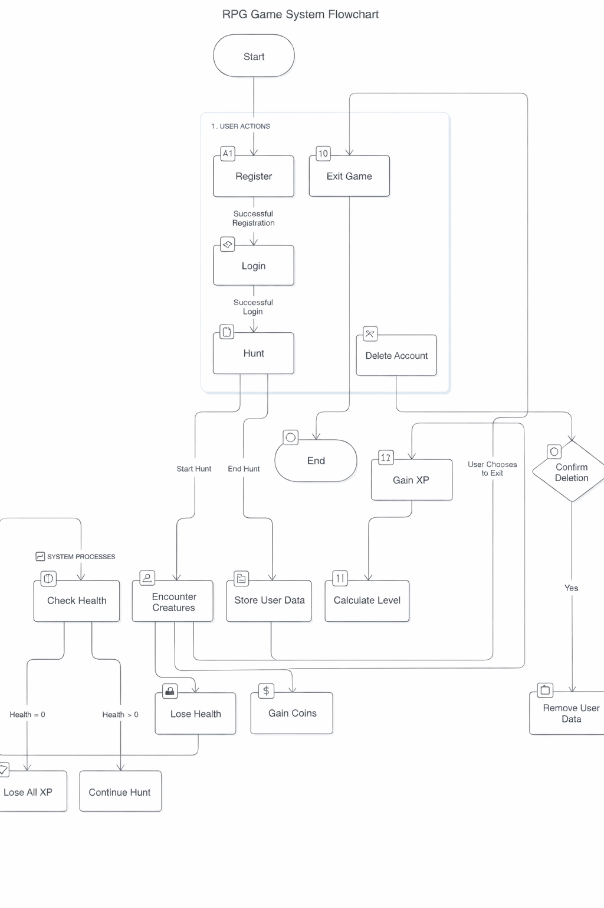

**5.7 Menu Design**

* The menu is the main place where the player controls the game. It shows all the available actions in a simple numbered list so the player can easily decide what to do next.
* The player just enters the number of the option they want, and the game performs that action. After the action is completed, the menu is shown again so the player can continue playing without any confusion.

**MENU**

**1. 🎯 Hunt**

**2. 🗺️ Adventure**

**3. 🧪 Heal using Life Potion**

**4. 🎒 View Inventory**

**5. 👤 View Profile**

**6. 🏪 Store**

**7. 🪵 Chop Wood**

**8. 🎁 Reward**

**9. 🛠️ Craft**

**10. 🗑️ Delete User**

**11. 🚪 Exit**

**5.8 Screen Design**

1. **System Testing**

### 6.1 Testing and Implementation

* Testing was done throughout the development of the project by running the game in the terminal after adding new features. Each time a feature was implemented, the game was played to check if it was working properly.
* When errors occurred, such as crashes, wrong outputs, or logical mistakes, the code was reviewed and fixed immediately. This ongoing testing helped keep the game stable while new features were being added.

### 6.2 Testing Methodology

* Manual testing was followed for this project. Since the game runs entirely in the command line, testing was done by selecting different menu options and observing how the system responds.
* Various situations were tested, including normal gameplay, invalid inputs, missing inventory items, cooldown limits, and login failures. This helped ensure that the game handles user actions correctly and does not break during gameplay.

### 6.3 Test Case Design

* Test cases were created based on the options available in the game menu. Each test case focused on checking one feature at a time and observing how player data such as health, experience points, inventory items, and overall statistics were updated during gameplay

|  |  |  |  |
| --- | --- | --- | --- |
| **Test Case ID** | **Menu Option** | **Description** | **Expected Result** |
| TC-01 | Register | Create a new user account | User account created successfully |
| TC-02 | Login | Login with valid credentials | User logged in |
| TC-03 | Login | Login with invalid credentials | Access denied |
| TC-04 | Hunt | Perform hunt action | XP, coins, and items updated |
| TC-05 | Adventure | Perform adventure | Health reduced or rewards gained |
| TC-06 | Chop Wood | Chop wood | Wood logs added to inventory |
| TC-07 | Store | Buy weapon or item | Inventory updated, stats affected |
| TC-08 | Craft | Craft Wooden Sword | Weapon crafted, attack increased |
| TC-09 | Craft | Craft Lucky Charm | Luck increased, cooldown applied |
| TC-10 | Heal | Use Life Potion | Health restored |
| TC-11 | Inventory | View inventory | Items displayed correctly |
| TC-12 | Profile | View profile | Player stats displayed |
| TC-13 | Reward | Claim reward | XP or coins added |
| TC-14 | Delete User | Delete account | User data removed |
| TC-15 | Exit | Exit game | Program terminates safely |

**Table No. 6.3.1**

**6.4 System Implementation Strategy**

* The system was implemented in a step-by-step manner to keep the development process simple and manageable. Basic features such as user registration, login, and menu navigation were implemented first.
* Once these core features were stable, gameplay functions like hunting, adventure, inventory handling, and profile viewing were added.
* Advanced features such as the store, crafting system, cooldown mechanisms, and luck attribute were implemented later. After adding each feature, the system was tested through the terminal to ensure correct behavior.
* This gradual implementation approach made it easier to identify errors, apply fixes, and maintain overall stability of the game.

## Conclusion

* This project helped in understanding how a role-playing game works at a basic level using Python. By building a text-based RPG, important programming concepts such as functions, data handling, file storage, and logic flow were learned and applied in a practical way.
* Features like combat, inventory management, crafting, and player progression were implemented step by step, keeping the system simple and easy to understand.
* Working on this project also improved problem-solving skills, as many errors were encountered during development and fixed through testing and debugging. Overall, the project successfully meets its objective of creating a simple yet functional RPG system while providing a good learning experience in Python programming

## Learning During Project Work

* Working on this project was a valuable learning experience. It helped in understanding how to break a large problem into smaller parts and implement them step by step.
* Through this project, practical knowledge of Python programming was gained, especially in areas like file handling, functions, dictionaries, and program flow control.
* The project also improved problem-solving skills, as many errors and logical issues were faced during development and resolved through testing and debugging. Additionally, it provided experience in designing a system, planning features, and improving code gradually.
* Overall, this project helped build confidence in programming and gave a better understanding of how real applications are developed.

### Online References

1. **W3Schools**, *Python Tutorial*.
   * Available at: https://www.w3schools.com/python/
   * Referred for understanding Python basics such as functions, dictionaries, loops, and file handling
2. **EPIC RPG Wiki**, *EPIC RPG Game Guide*.

* Available at: https://epic-rpg.fandom.com/wiki/EPIC_RPG_Wiki
* Referenced for understanding RPG game concepts, items, progression, and gameplay mechanics

***This project marks the end of an important phase of my academic journey. Building this game was not just about writing code, but about learning, experimenting, failing, fixing mistakes, and improving step by step. It reflects the effort, patience, and growth I experienced throughout my final year, making this project a memorable and meaningful conclusion to my studies.***